A CRM Application to Handle the Clients and their property Related Requirements

**Introduction**

Dreams World Properties leverages Salesforce to enhance customer relationship management and optimize real estate operations. By integrating Salesforce with their website, Dreams World Properties automates the process of capturing customer interactions, preferences, and details in real-time. The system categorizes clients into approved and non-approved users, allowing personalized property recommendations for approved clients, while offering broader selections to others. This seamless integration not only streamlines operations but also elevates customer engagement, delivering a tailored experience that fosters growth in the competitive real estate market. With Salesforce's robust features, Dreams World Properties aims to improve efficiency, client satisfaction, and market reach.

**Definitions:**

**Customer Relationship Management (CRM)** refers to a strategy, technology, and process that companies use to manage and analyze customer interactions and data throughout the customer lifecycle. The primary goal of CRM is to enhance customer relationships, improve customer retention, and drive sales growth.

**Salesforce**: One of the leading CRM platforms, offering extensive features for sales, service, marketing, and analytics.

**Salesforce Tools Used:**

**Lightning Web Component (LWC):** is a modern framework for building reusable, dynamic web interfaces in Salesforce. It's built on native web standards, allowing developers to create components with better performance, maintainability, and scalability. LWC leverages modern web technologies such as custom elements, templates, shadow DOM, modules, and ECMAScript (JavaScript) to enhance user experience in Salesforce applications.

**Apex:** It is a strongly typed, object-oriented programming language used by developers to execute flow and transaction control statements on the Salesforce platform. It is similar to Java and enables developers to add complex business logic to system events like button clicks, record updates, and Visualforce pages. Apex is designed to be tightly integrated with Salesforce, allowing for the execution of customized processes and automation within Salesforce's cloud environment.

**Approval Process** in Salesforce is an automated process that allows records (such as leads, opportunities, contracts, or any custom object) to be submitted for approval based on specific criteria. It streamlines workflows by routing records to designated approvers and ensures that business-critical decisions are properly reviewed and approved by authorized users. The approval process defines the steps, actions, and logic that a record must go through for approval.

**Flows** in Salesforce are powerful automation tools that enable you to automate complex business processes without writing code. Salesforce Flows are part of the Salesforce Flow Builder, which allows you to build applications and automate tasks by visually designing a process. Flows are highly flexible and can be used to update records, create records, delete records, send emails, and more based on user inputs, data, or events.

**Other Tools:**

**Visual Studio Code (VS Code)** is a free, open-source code editor developed by Microsoft, designed for developers and programmers. It supports a wide variety of programming languages, including JavaScript, Python, C++, and many others.

One of the key features of VS Code is its rich ecosystem of extensions, which allows users to customize their development environment. These extensions can add new languages, debuggers, themes, and other tools, enhancing productivity and supporting a tailored workflow. The editor is built on a lightweight framework, ensuring it runs smoothly even on less powerful hardware.

VS Code also boasts built-in features such as IntelliSense, which provides intelligent code completion based on variable types and function definitions, as well as real-time collaboration through Live Share. Its integrated terminal allows developers to run shell commands directly from the editor, streamlining the development process.

Moreover, VS Code is equipped with powerful debugging tools that enable developers to set breakpoints, inspect variables, and navigate through code seamlessly. Its Git integration facilitates version control, allowing users to manage repositories directly within the editor.

Overall, Visual Studio Code stands out as a versatile and efficient coding tool, offering a balance between functionality and performance, making it a popular choice among developers of all levels.

|  |  |  |
| --- | --- | --- |
|  |  |  |

**Objective of the CRM Application**

The primary objective of the CRM (Customer Relationship Management) Application is to create a centralized platform that streamlines the management of client relationships and property-related requirements. This application aims to enhance customer service, improve communication, and optimize operational efficiency for real estate businesses. Specifically, the objectives include:

1. **Client Management**: To provide a comprehensive database for storing client information, including contact details, preferences, and communication history, enabling personalized and timely interactions.
2. **Property Management**: To facilitate the management of property listings, including detailed descriptions, pricing, availability, and related documentation, allowing for efficient tracking and updates.
3. **Lead Tracking**: To implement tools for tracking and managing leads, ensuring that potential clients are effectively followed up on and nurtured through the sales pipeline.
4. **Task Automation**: To automate routine tasks such as scheduling appointments, sending reminders, and generating reports, thereby allowing staff to focus on more strategic activities.
5. **Reporting and Analytics**: To provide analytical tools for generating reports on sales performance, client interactions, and property trends, aiding in data-driven decision-making.
6. **User-Friendly Interface**: To ensure the application is intuitive and accessible, allowing users to quickly adapt and maximize its features without extensive training.
7. **Integration Capabilities**: To enable seamless integration with existing tools and platforms (e.g., email, calendars, and marketing tools) to create a cohesive workflow.

**Scope of the CRM Application**

The scope of the CRM Application encompasses the following key areas:

1. **Target Users**:
   * Real estate agents and brokers
   * Property managers
   * Marketing teams
   * Administrative staff
2. **Core Features**:
   * **Client Database**: A robust database to store and manage client profiles, interaction history, and preferences.
   * **Property Listings**: A module to create, manage, and display property listings, including features for images, descriptions, and availability status.
   * **Lead Management**: Tools to capture, track, and nurture leads, including automated follow-up reminders and task assignments.
   * **Communication Tools**: Integrated messaging and email capabilities to facilitate communication between agents and clients.
   * **Reporting Dashboard**: A dashboard for visualizing key metrics, including lead conversion rates, sales performance, and client engagement levels.
3. **Integration and Compatibility**:
   * The application will be designed to integrate with third-party tools such as email services (e.g., Gmail, Outlook), calendar applications, and marketing platforms (e.g., Mailchimp).
   * The system will be compatible with both desktop and mobile devices to accommodate users’ varying preferences for accessing the application.
4. **Data Security and Privacy**:
   * Implementation of robust security measures to protect sensitive client information, including data encryption, secure user authentication, and compliance with data protection regulations (e.g., GDPR).
   * Features to allow clients to manage their own data privacy settings and consent for communication.
5. **Customization and Scalability**:
   * The application will allow for customization based on the specific needs of different real estate businesses, including customizable workflows, fields, and reporting metrics.
   * Scalability to support the growth of user bases and increase in data volume over time without compromising performance.
6. **Support and Training**:
   * Provision of user support, including tutorials, documentation, and customer service, to assist users in navigating the application and resolving issues.
   * Training programs to ensure users are well-equipped to utilize all features of the CRM effectively.

**Conclusion**

In conclusion, the CRM Application is designed to address the specific needs of real estate professionals by providing a robust tool for managing client relationships and property-related tasks. By enhancing efficiency, improving communication, and enabling data-driven decision-making, the application aims to support the overall growth and success of real estate businesses.

**Snapshots:**

Form:

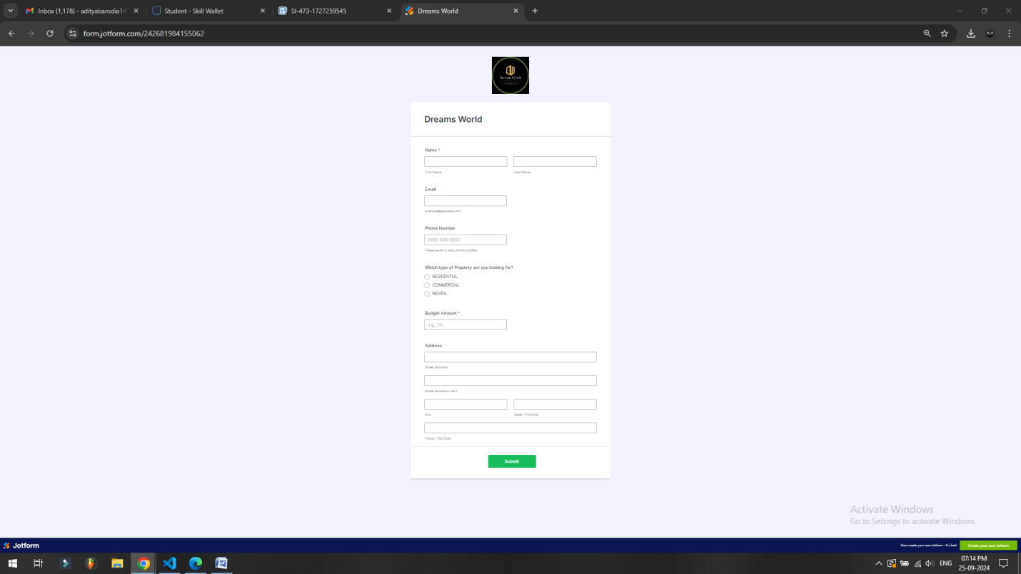

Code:

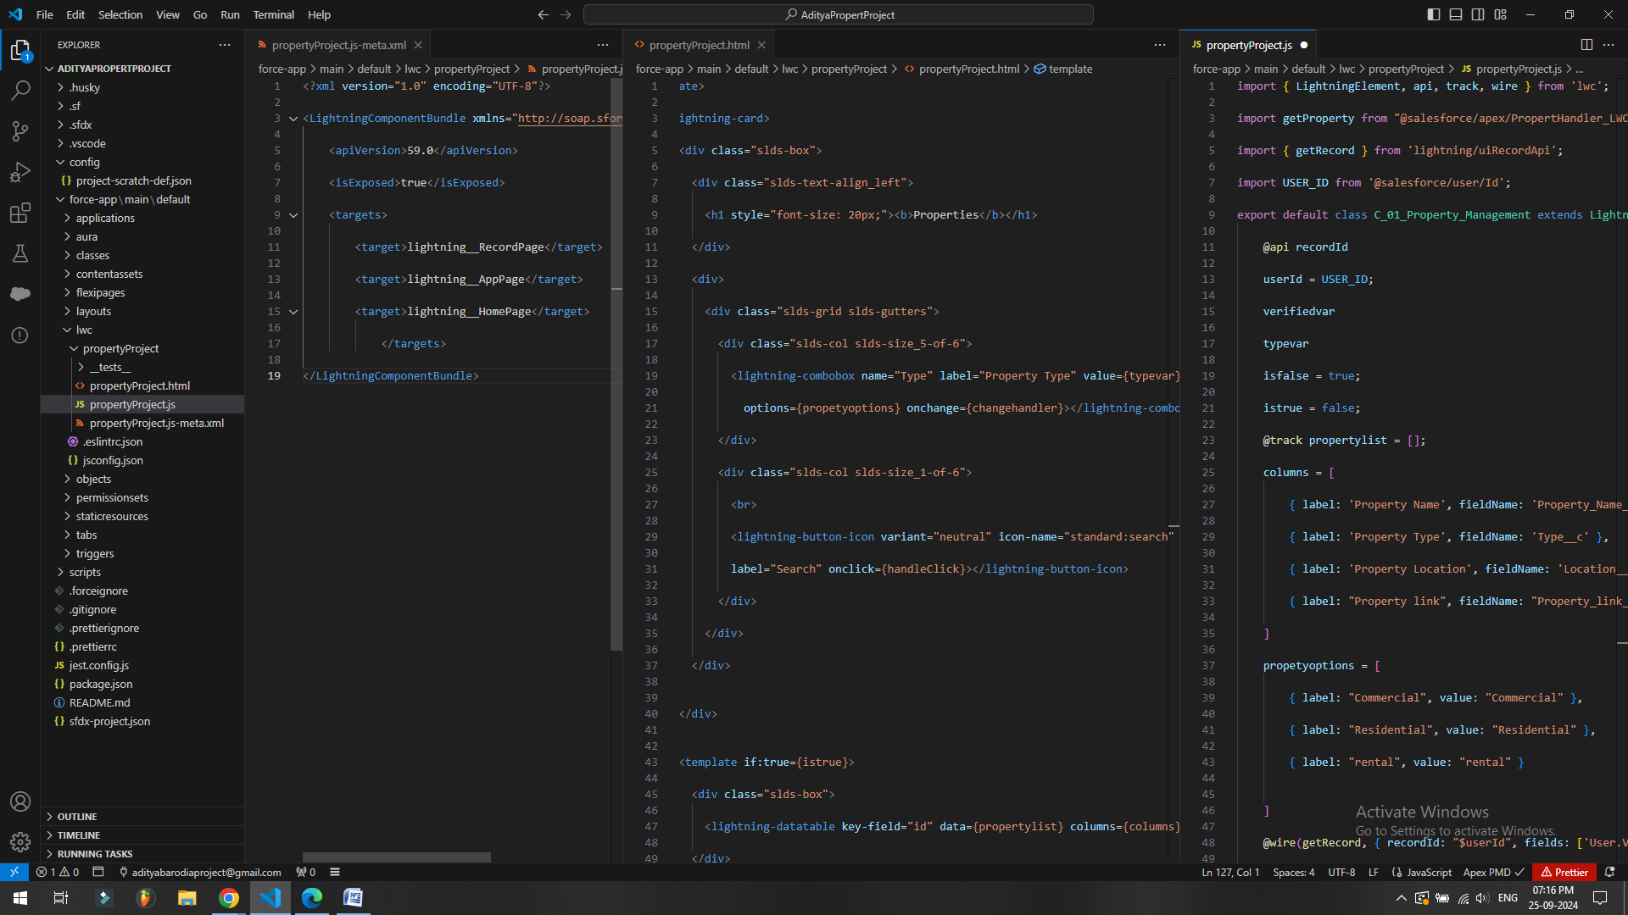

Entries Reflecting:

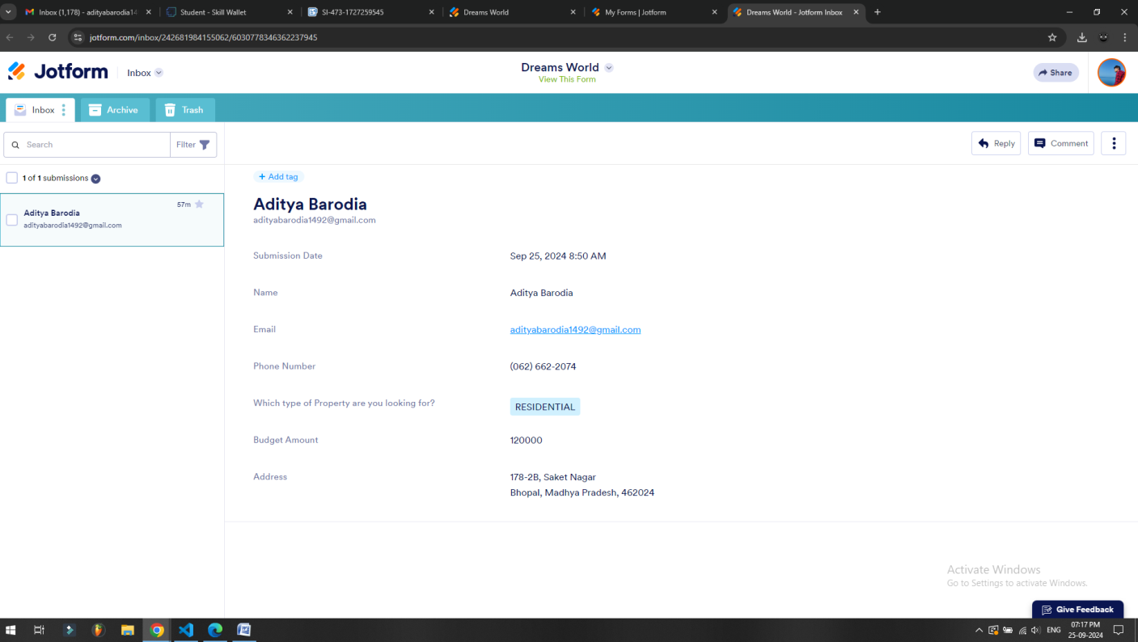

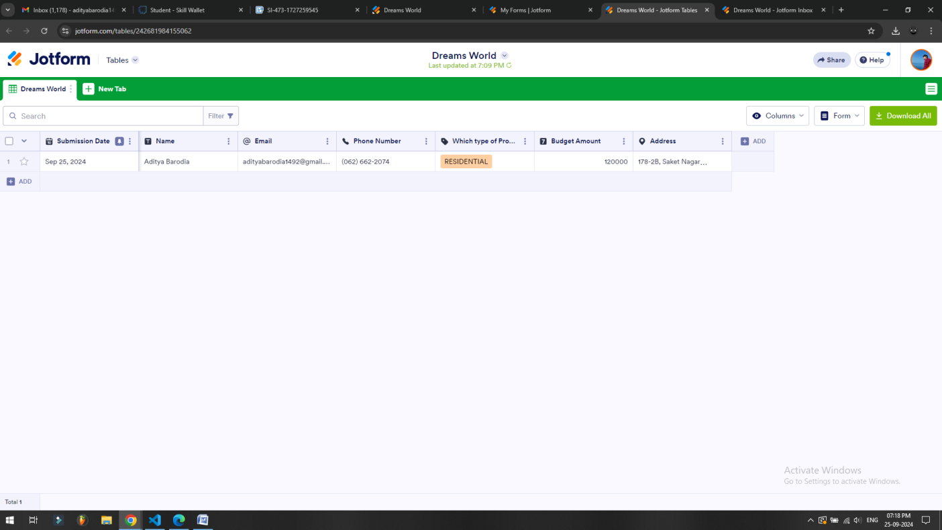

Lightning Web App (with VSCode project integration)

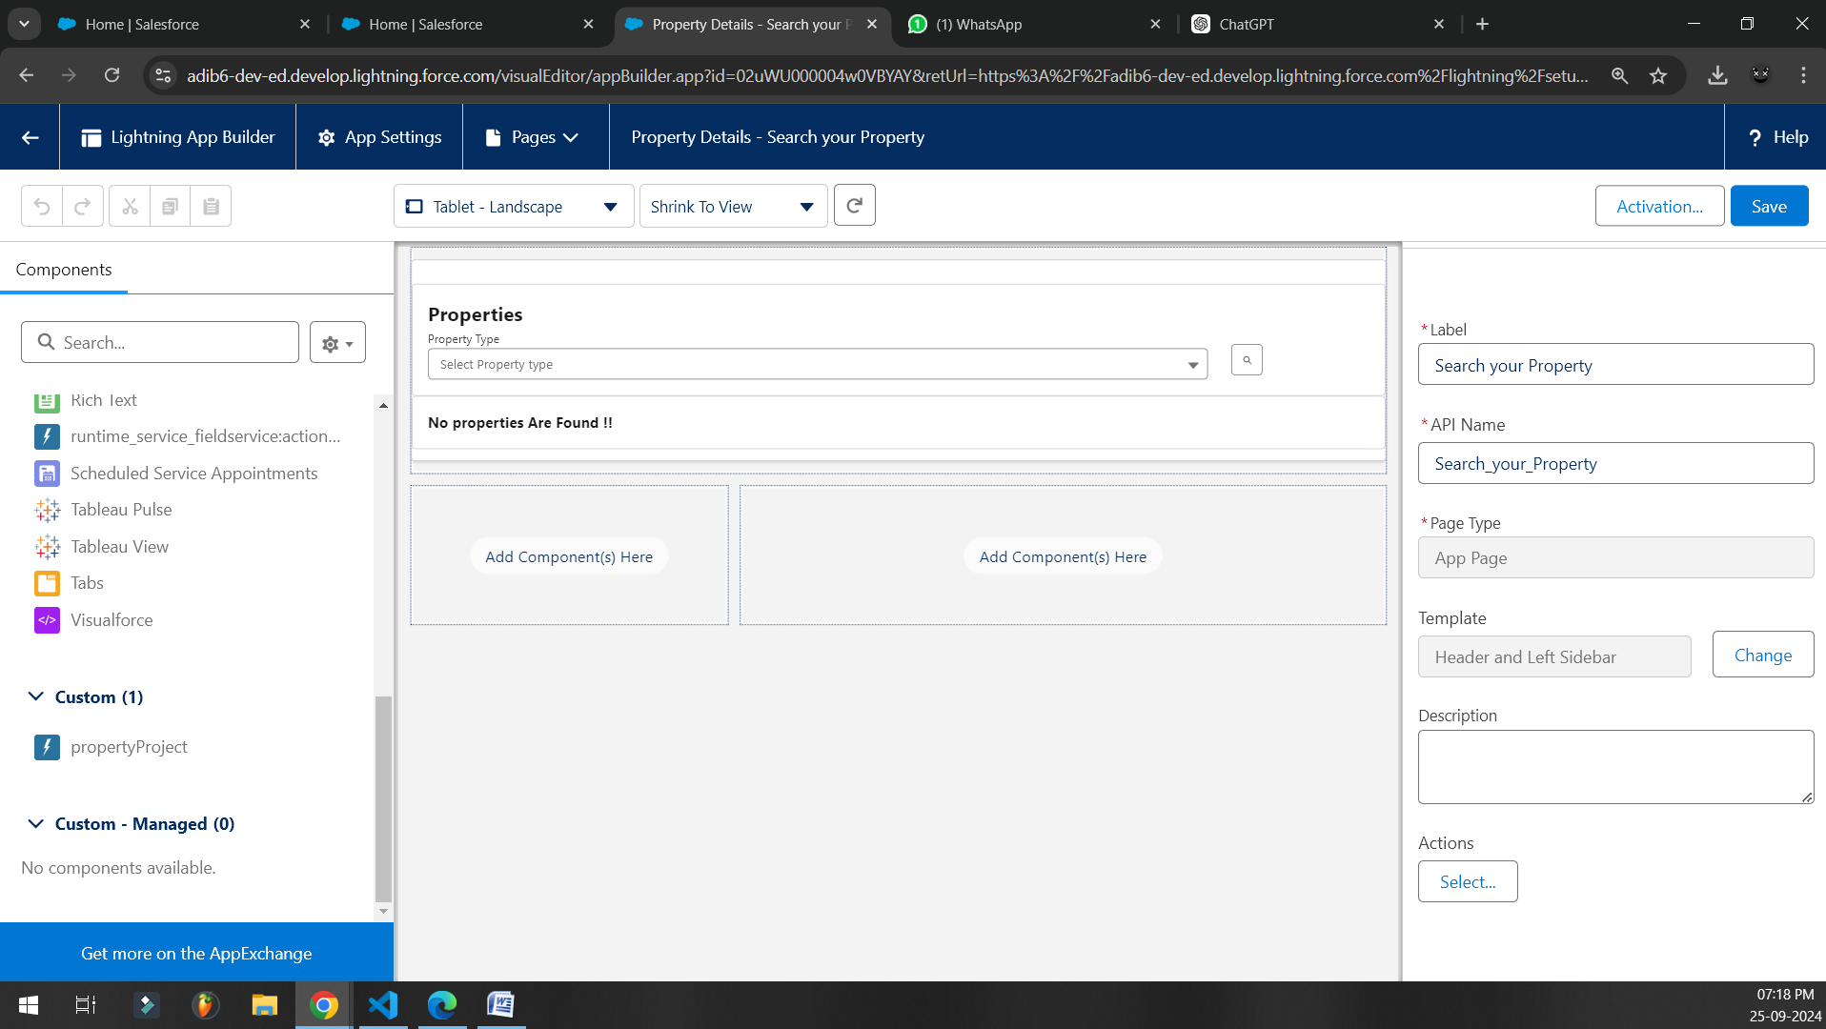

Approval Flow:

